Given an m x n matrix, return *a new matrix*answer*where*answer[row][col]*is the****rank****of*matrix[row][col].

The **rank** is an **integer** that represents how large an element is compared to other elements. It is calculated using the following rules:

* The rank is an integer starting from 1.
* If two elements p and q are in the **same row or column**, then:
  + If p < q then rank(p) < rank(q)
  + If p == q then rank(p) == rank(q)
  + If p > q then rank(p) > rank(q)
* The **rank** should be as **small** as possible.

It is guaranteed that answer is unique under the given rules.

**Example 1:**

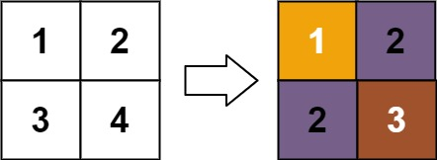

**Input:** matrix = [[1,2],[3,4]]

**Output:** [[1,2],[2,3]]

**Explanation:**

The rank of matrix[0][0] is 1 because it is the smallest integer in its row and column.

The rank of matrix[0][1] is 2 because matrix[0][1] > matrix[0][0] and matrix[0][0] is rank 1.

The rank of matrix[1][0] is 2 because matrix[1][0] > matrix[0][0] and matrix[0][0] is rank 1.

The rank of matrix[1][1] is 3 because matrix[1][1] > matrix[0][1], matrix[1][1] > matrix[1][0], and both matrix[0][1] and matrix[1][0] are rank 2.

**Example 2:**

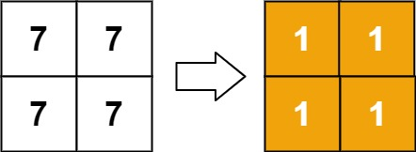

**Input:** matrix = [[7,7],[7,7]]

**Output:** [[1,1],[1,1]]

**Example 3:**

**Input:** matrix = [[20,-21,14],[-19,4,19],[22,-47,24],[-19,4,19]]

**Output:** [[4,2,3],[1,3,4],[5,1,6],[1,3,4]]

**Example 4:**

**Input:** matrix = [[7,3,6],[1,4,5],[9,8,2]]

**Output:** [[5,1,4],[1,2,3],[6,3,1]]

**Constraints:**

* m == matrix.length
* n == matrix[i].length
* 1 <= m, n <= 500
* -109 <= matrix[row][col] <= 109